



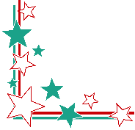



SCORE:





YOU FINISH THE FIRST STAGE!



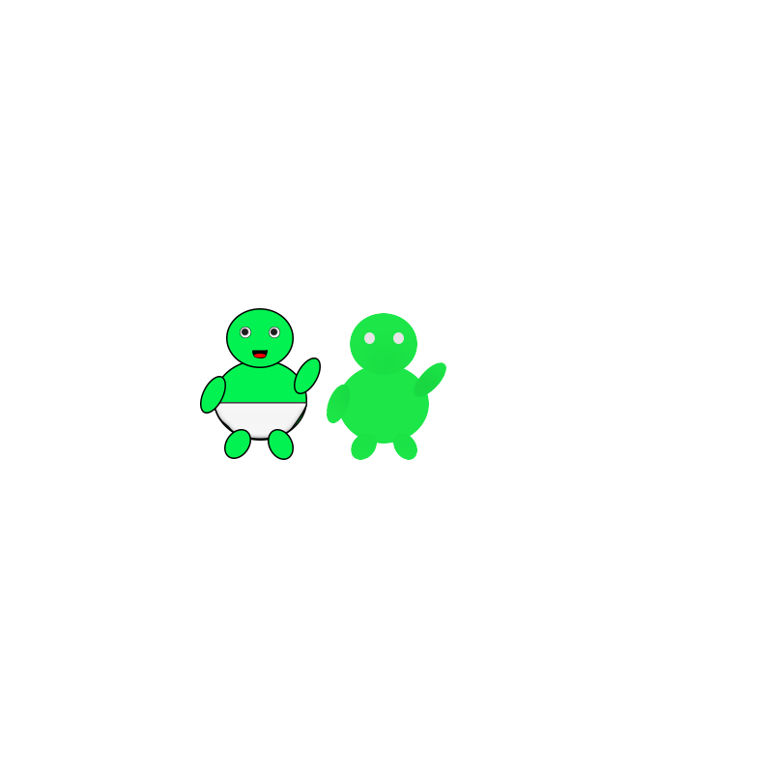

Tap *LEFT* to move LEFT

Tap *RIGHT* to move RIGHT

**Instruction:**

On the next level, you have to catch my favorite food and reach 500 points, otherwise, you can’t continue to the next level. ☹





Could you please tell me why or how Google named

their series of versions after desserts and sweets treats?





Yes! That is correct. Cupcake is the first version of Android that has name but actually it is the second version because the first one doesn’t have name.





So are you ready to answer the questions?

**IT IS SO SWEET LIKE YOU**



What is the first version of android that starts with letter “C”? ☺





SCORE:



*Touch* the screen where the food Is placed.





**Instruction:**

On this mini game, ☺ you have to tap my favorite food, otherwise, the game is over ☹





Do you want to continue?

YOU MADE IT!!!

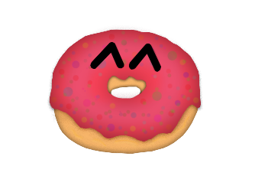



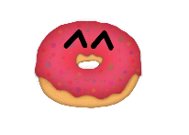

I KNEW YOU CAN DO IT!

Do you wish to continue?

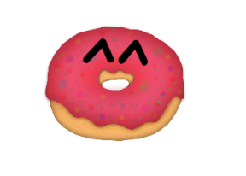

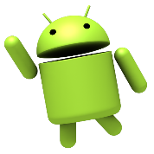

So what’s the next name after the cupcake version?



GAME

OVER



SCORE:

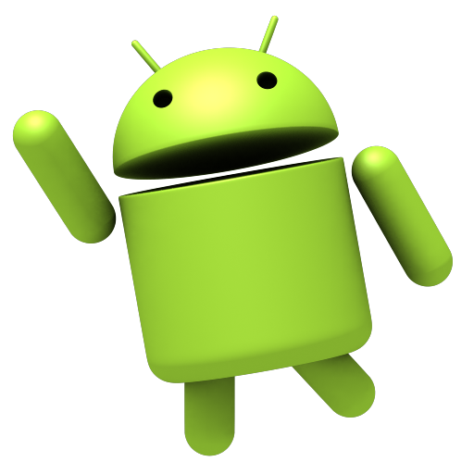



**I know you want Donut!**

I like Donut, too, because it is so sweet! But they said that eating too much Donut can lead to weight gain. ☹ But they also said that eating Donut can help if you are having a hard time to concentrate or remember things because of its sugar. WOW!





Why sugar is also important

In our body?

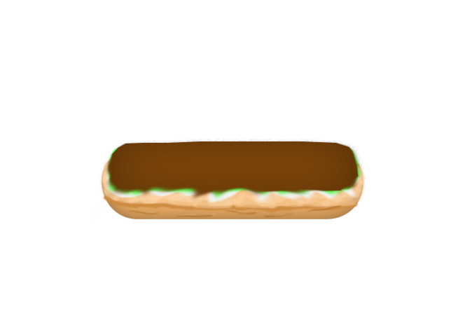

**Instruction:**

On this mini game, you have to catch all the sweet android versions, otherwise the game is over. You have to reach 300 points in order for you to go to the next level. ☺



Tap *LEFT* to move LEFT

Tap *RIGHT* to move RIGHT



SCORE:



it's true that probiotics are naturally found in yogurt, but those healthy bacteria don't always make their way into your digestive tract because according to Marshal Fong, extreme temperatures can prevent probiotics from surviving and getting to where they can do the most benefit.



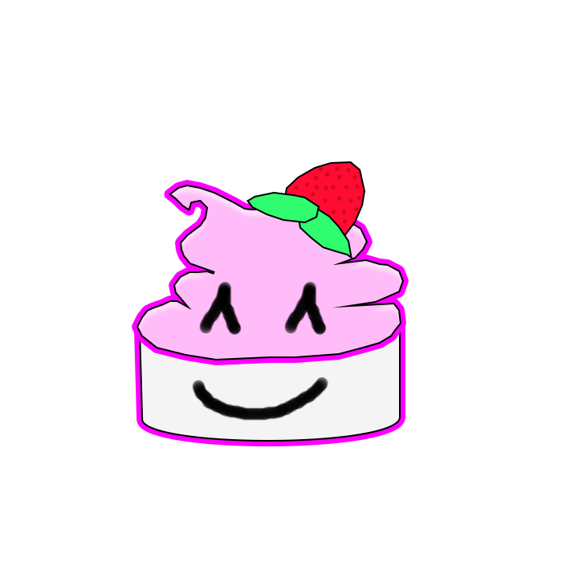

















SCORE:



What can be the factor that the probiotics in frozen yogurt can be hinder?

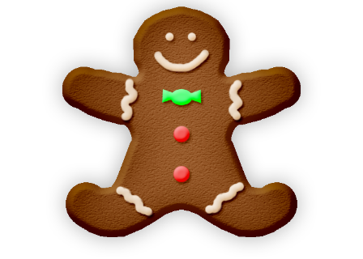

Did you know that Gingerbread originated in the East? And it is said to have been brought to Europe by a monk and was used to treat indigestion and upset stomachs?



*Touch* the screen where the food Is placed.

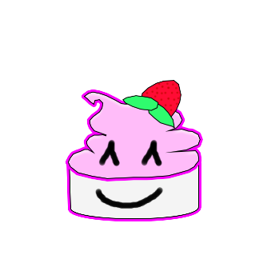

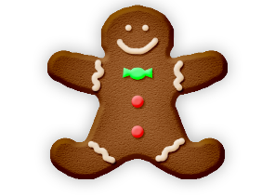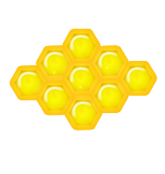

**Instruction:**

On this mini game, ☺ you have to tap the previous sweets version of Android, otherwise, the game is over. ☹ You have to reach 500 points in order to go the last level.



HELLO! This is the last level of the game! Hope you do great!



This next version of Android was publicly released on October 19, 2011 and this Android 4.0 was theoretically compatible with any 2.3.x device in production of that time.



This Android 4.0 has a feature that has ability to shut down application from the recent app list with a swipe, to integrate screenshot capture by holding down the Power and Volume-Down buttons, to unlock handsets using facial recognition software and many more.





SCORE:



SCORE:





SCORE:



Did you know that Jellybean is associated with Easter because of its egg-like shape? And jellybean was once used as slang for the kind of guy you don’t bring home to Mom and Dad! Ouch!



Last but not the least, what is the next version after the Jellybean?

T

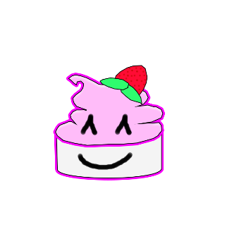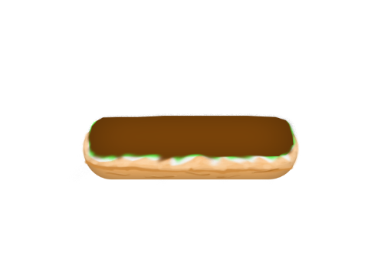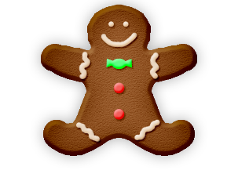

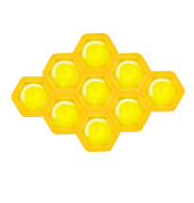



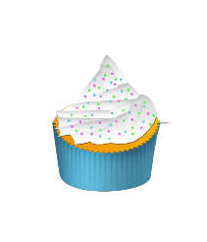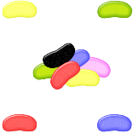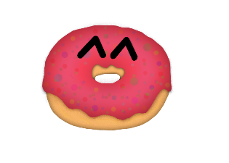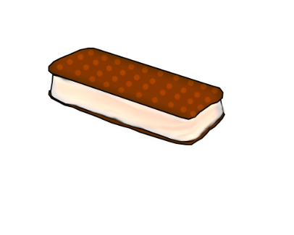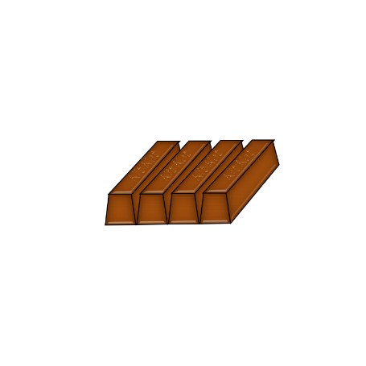



**Instruction:**

You have to get all the sweet versions of Android starting from Cupcake to KitKat, otherwise the game is over. Tap the upper right or left and lower right or left of the screen to move the character.





Do you wish to continue?

I KNEW YOU CAN DO IT!